Lecture 01

**NW2-How-to-configure-IP-Gateway**

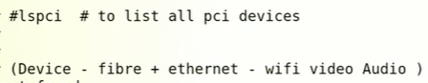

$ lspci -vvv à ”vvv” for detailed information

**$ lspci |grep -i ether à to list ethernet PCI details**



Similarly all PCI devices can be searched e.g audio etc





In this pic 4 ports are associated with respective drivers “**eth0** and so on”

* To know IP address command is
* $ ifconfig -a
* 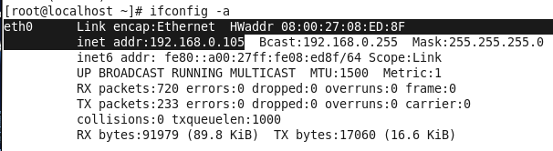
* To know oroperties of network card
* $ ethctool <driver_name>
* $ ethtool eth0
* 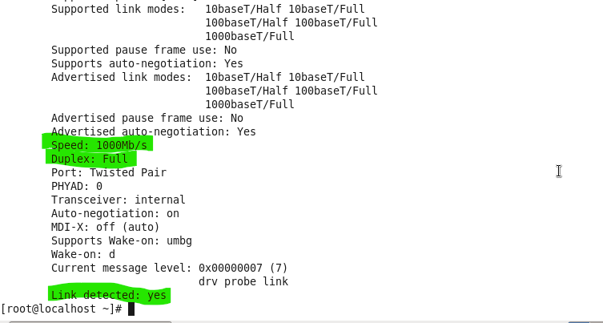
*  à it will change it IP for the time being, if the system is rebooted, this Ip will be lost and needed to be configured again,
* To assign an IP permanently the procedures if to edit “ifconfig” file
* $ vi /etc/sysconfig/network-scripts/ifcfg-eth0 à for make permanent changes or make IP static
* Configuration,

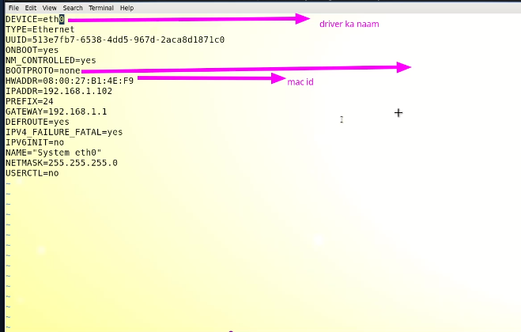

**BOOTPROTO** must be “yes”, set to “static” if Static IP is to be assigned and set to “DHCP” for automatic IP assignment from router

* 5 enteries are must in order to config successfully,
  + Device
  + Boorproto
  + MAC
  + IP
  + NetMask
* Now reloading the config file by
* **$ service network restart**

**What is gateway and how to configure it**



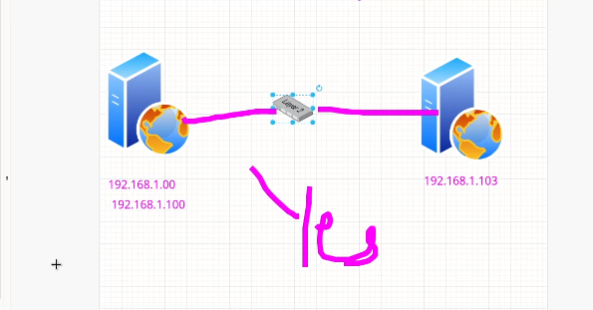

* Two computers can “ping” eachother if in same network
* Same network means , two computers has IP between,
* **192.168.1.0 to 192.168.1.255**
* Network part is “192.168.1”
* IP part is “255”
* So IPs can be assing from 1 to 254 from this range
* In this scenarion no router and gateway is required to ping
* “0” is called --> network IP
* “255” is called --> broadcast IP
* 0 and 255 can’t be used
* So remaining IPs from range 1 – 254 can be used
* A “switch” workes like a “lift” in same network but if the network is different, switch can’t handle it.
* The solution is a **“router” -->** different networks 192.168.0.1 & 192.168.1.1
* Router means to communicate b/w two different netwrks
* 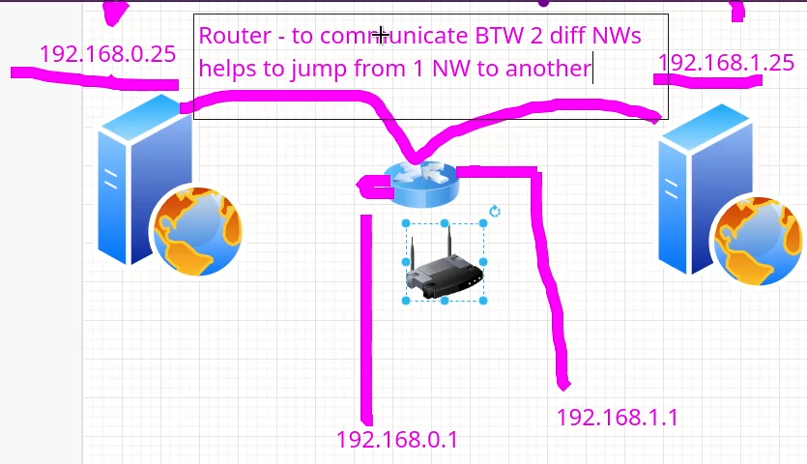
* In above scenario two computers still cant ping each other
* to ping a gate way is to be configured.
* **Configuring gateway**
* How to check
* $ rout e–n --> to chck gateway
* To addgateway --> administrator must be contacted
* $ rout add default <Ip provided by ISP>
* To make it permanent edit “ifcfg” file
* And then service restart.
* $ **service network restart** --> but it will restart all interface i.e eth0, eth1, eth2, eth3 ...
* For a specific interface,
* 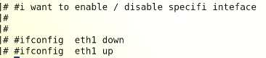
* Or
* 
* 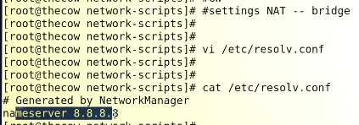
* <https://www.itzgeek.com/how-tos/linux/centos-how-tos/how-to-configure-static-ip-address-in-centos-7-rhel-7-fedora-26.html>
* <https://www.youtube.com/watch?v=K-_wfLZeIzg>

# **How To Configure Static IP Address in CentOS 7 / RHEL 7**

Setting up the network and bringing servers into the network is the primary administration task for any system administrator.

In some cases, these tasks are automated using DHCP (Dynamic Network Configuration Protocol) which takes care of assigning IP Address to Desktop/Servers.

READ: [How To configure DHCP server on CentOS 7, Ubuntu 18.04 & Debian 9](https://www.itzgeek.com/how-tos/linux/ubuntu-how-tos/install-and-configure-dhcp-server-on-centos-7-ubuntu-14-04.html)

But, if you go to the bigger organizations, they use static (manual) IP to avoid network issues due non-availability of DHCP servers.

## Configure Static IP Address in CentOS 7 / RHEL 7

Let us configure our system for the following information.

**IP Address:** 192.168.1.10  
**Netmask:** 255.255.255.0  
**Gateway (Router):**192.168.1.1  
**DNS Server 1:** 192.168.1.1  
**DNS Server 2:** 8.8.8.8  
**Domain Name:** itzgeek.local

### Find the available network interfaces on your system

You can use any one of the below commands to list down the available network interfaces on the system.

ifconfig -aCOPY

OR

ip aCOPY

### Choose the desired network interface

The output of ifconfig -a may look like below. Here, I wish to change the IP address of enp0s3.

**enp0s3**: flags=4163<UP,BROADCAST,RUNNING,MULTICAST> mtu 1500

inet 192.168.1.7 netmask 255.255.255.0 broadcast 192.168.1.255

inet6 fd50:1d9:9fe3:1400:a00:27ff:fe98:676 prefixlen 64 scopeid 0x0

inet6 fe80::a00:27ff:fe98:676 prefixlen 64 scopeid 0x20

ether 08:00:27:98:06:76 txqueuelen 1000 (Ethernet)

RX packets 2997 bytes 3497708 (3.3 MiB)

RX errors 0 dropped 0 overruns 0 frame 0

TX packets 1487 bytes 135487 (132.3 KiB)

TX errors 0 dropped 0 overruns 0 carrier 0 collisions 0

lo: flags=73<UP,LOOPBACK,RUNNING> mtu 65536

inet 127.0.0.1 netmask 255.0.0.0

inet6 ::1 prefixlen 128 scopeid 0x10

loop txqueuelen 0 (Local Loopback)

RX packets 0 bytes 0 (0.0 B)

RX errors 0 dropped 0 overruns 0 frame 0

TX packets 0 bytes 0 (0.0 B)

TX errors 0 dropped 0 overruns 0 carrier 0 collisions 0

COPY

### Configure the Static IP Address

#### Method 1

In this method, we will edit the network interface file found under /etc/sysconfig/network-scripts/ directory. For interface enp0s3, the file name would be ifcfg-enp0s3.

vi /etc/sysconfig/network-scripts/ifcfg-enp0s3COPY

Update the interface file as per the requirement.

HWADDR=08:00:27:98:06:76

TYPE=Ethernet

**# Static IP Address #**

BOOTPROTO=none

**# Server IP #**

IPADDR=192.168.1.10

**# Netmask #**

NETMASK=255.255.255.0

**# Default Gateway IP #**

GATEWAY=192.168.1.1

**# DNS Servers #**

DNS1=192.168.1.1

DNS2=8.8.8.8

DEFROUTE=yes

IPV4_FAILURE_FATAL=no

**# Disable ipv6 #**

IPV6INIT=no

**# Device Name #**

NAME=enp0s3

DEVICE=enp0s3

**# Optional – This is system specific and can be created using ‘uuidgen enp0s3’ command #**

UUID=02d4a47b-3dbe-4e0b-ae4b-841a8c58e807

**# Activate on Boot #**

ONBOOT=yes

**# Default Domain Search #**

DOMAIN=itzgeek.localCOPY

#### **Method 2**

You can also use nmtui, a text-based user interface for configuring network interfaces.

You would need to install NetworkManager Text User Interface yum install NetworkManager-tui package for the nmtui tool.

nmtuiCOPY

Select **Edit a connection** and press **Enter**.

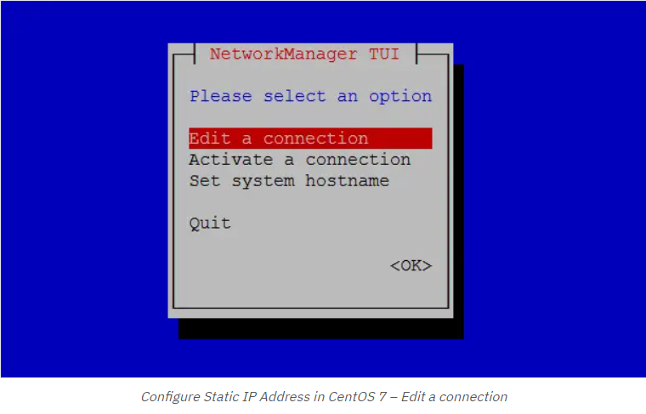

**Choose the network interface** and then**Edit**.

Configure Static IP Address in CentOS 7 – Choose the network interface

**Set the IP Address** and enter **OK**.

Restart Network

Finally, restart the network service using the following command to have these changes take effect.

systemctl restart networkCOPY

## Verify Static IP Address

Use ifconfig -a command to verify the static ip address.

enp0s3: flags=4163<UP,BROADCAST,RUNNING,MULTICAST> mtu 1500

**inet 192.168.1.10 netmask 255.255.255.0** broadcast 192.168.1.255

inet6 fd50:1d9:9fe3:1400:a00:27ff:fe98:676 prefixlen 64 scopeid 0x0

inet6 fe80::a00:27ff:fe98:676 prefixlen 64 scopeid 0x20

ether 08:00:27:98:06:76 txqueuelen 1000 (Ethernet)

RX packets 55 bytes 6637 (6.4 KiB)

RX errors 0 dropped 0 overruns 0 frame 0

TX packets 84 bytes 12745 (12.4 KiB)

TX errors 0 dropped 0 overruns 0 carrier 0 collisions 0

lo: flags=73<UP,LOOPBACK,RUNNING> mtu 65536

inet 127.0.0.1 netmask 255.0.0.0

inet6 ::1 prefixlen 128 scopeid 0x10

loop txqueuelen 0 (Local Loopback)

RX packets 0 bytes 0 (0.0 B)

RX errors 0 dropped 0 overruns 0 frame 0

TX packets 0 bytes 0 (0.0 B)

TX errors 0 dropped 0 overruns 0 carrier 0 collisions 0

COPY

Also, verify the DNS server entries.

cat /etc/resolv.confCOPY

**Output:**

# Generated by NetworkManager

search itzgeek.local

nameserver 192.168.1.1

nameserver 8.8.8.8COPY

Conclusion

That’s All. I hope you have learned how to configure a static IP address on [CentOS 7 / RHEL 7](https://www.itzgeek.com/tag/centos-7).